CSC 425 525 Project Report Template (Project Title)

(For project 3, you have to do 1-6 for each sub-project)

Instructor: Dr. Junxiu Zhou

Semester: Fall 2020

Team Members: Nicholas Boldery, Trevor Applegate

SVM Implementation

1. Introduction

Introduction of your understanding of the project

2. Implementation Process and Results

Here please explain your implementation process steps of your project.

Ran whole SVM through a loop appending both the test size and accuracy of each SVM run to the list before plotting it at the end.

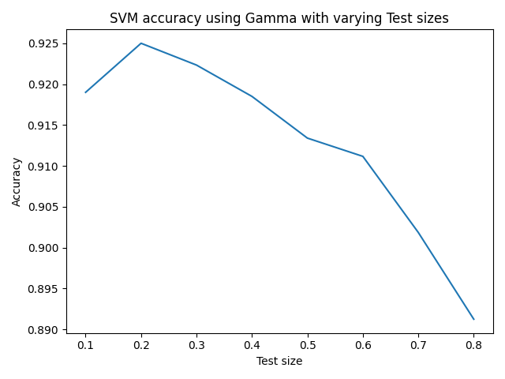

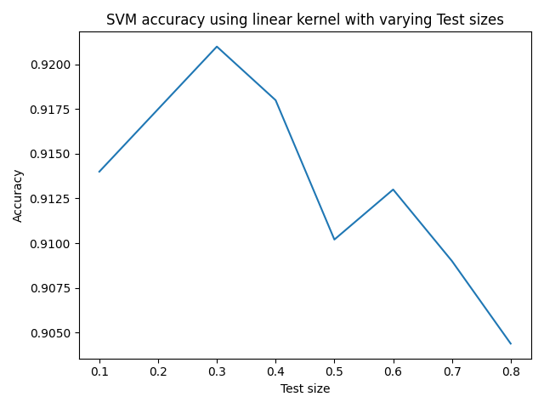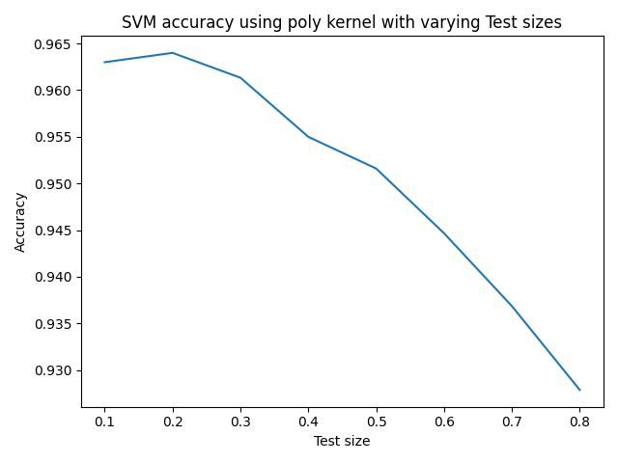

3. Answer for Questions

4. Bonus Implementation and Results (if applicable)

5. Team Members Responsibility Statement

6. Conclusion

Decision Tree Implementation

1. Introduction

Introduction of your understanding of the project

2. Implementation Process and Results

Here please explain your implementation process steps of your project.

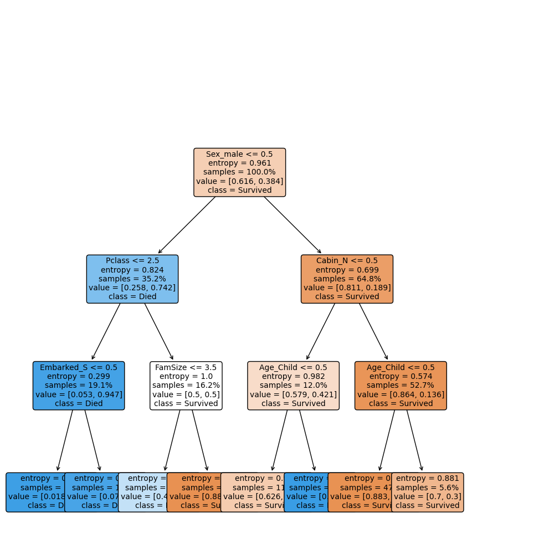

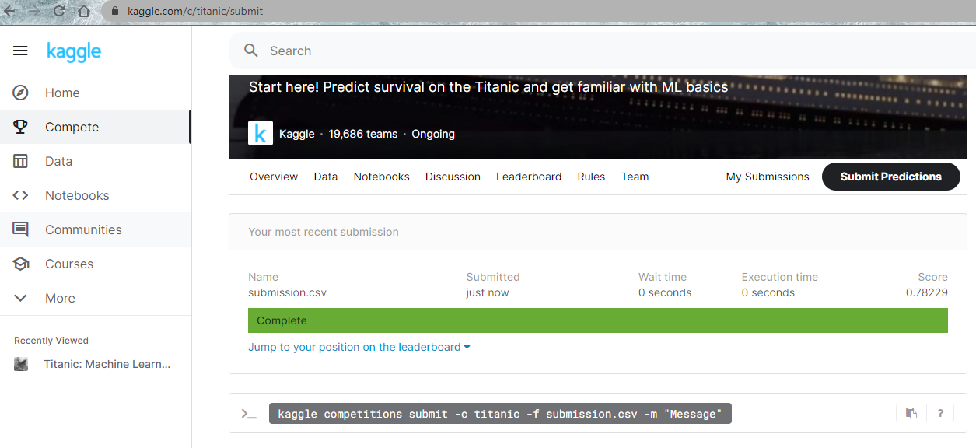

3. Answer for Questions

4. Bonus Implementation and Results (if applicable)

5. Team Members Responsibility Statement

6. Conclusion

Genetic Algorithm Implementation

1. Introduction

Introduction of your understanding of the project

2. Implementation Process and Results

Here please explain your implementation process steps of your project.

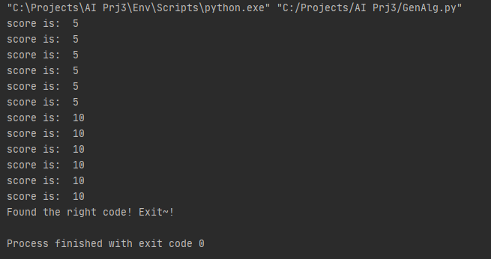

3. Answer for Questions

4. Bonus Implementation and Results (if applicable)

5. Team Members Responsibility Statement

6. Conclusion